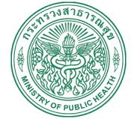

Thai Care Cloud
A unified health database and health services for Thailand

Data entry: Manually, Voice, Biosensor, etc.

EzForm
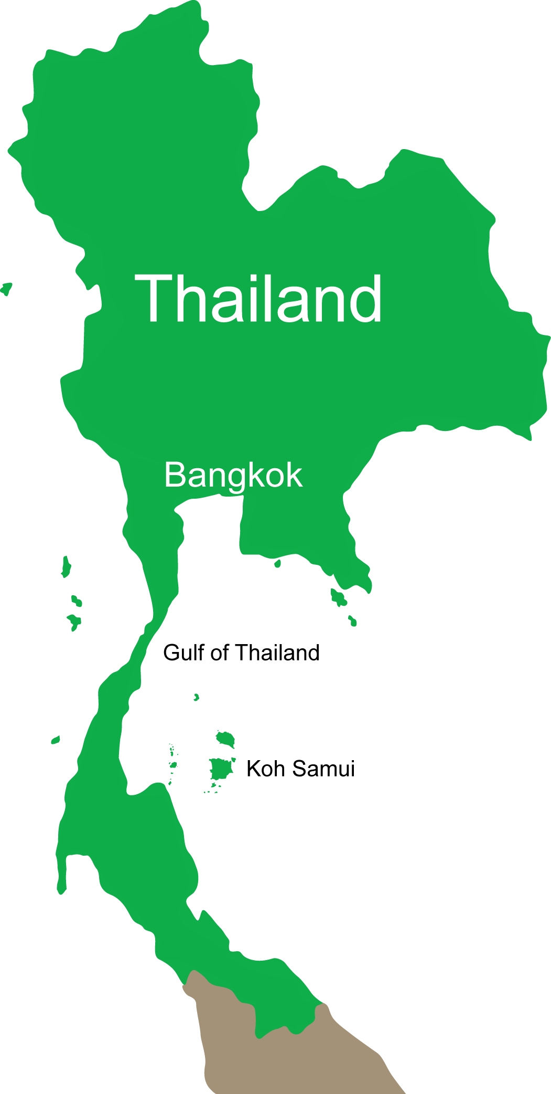
Data Processing
EzDashBoard
EzModule
Data Tools
Who?
OV-CCA

Do what?
Thai COC
Big data mining
LOINC, SNOMED-CT,

HL7, ICD10, ICD9CM
Improve care
Reduce cost
Purify Tools
When?
Many more

National HIS
Isan Cohort
Thai Care Cloud
CASCAP Tools
52 Files
Precision care
Line
e-Mail
Telegram
Many more

Cancer Clinic
Security & Confidentiality
Borderless HIS
Any data

CID 13 digits
CKDNET

EMR & EHR
Alert & Action
Report & Support
TDC

Data transferred automatically from HIS & LIS

* OV = Opisthorchis viverrini; CCA = Cholangiocarcinoma; COC = Continuity of Care; TDC = Thai Database Connector; CKDNET = Chronic Kidney Diseases Prevention in the Northeast of Thailand; HIS = Health Information System; LIS = Laboratory Information System; KPI = Key performance indicator; EMR = Electronic medical record; PHR = Personal health record; CID = Citizen identification number

Thai Care Cloud has been developed based on PHP-MySQL under YII2 Framework. It’s a web application that is free of charge for public use. Key developers are at the Data Management and Statistical Analysis Center (DAMASAC), Faculty of Public Health, Khon Kaen University, under the mission of the KKU's 50 years of social devotion.
Faculty of Public Health, Khon Kaen University
Data Management and Statistical Analysis Center (DAMASAC)

